Express – Advance Topics

1. Middleware
2. Configurations
3. Debugging
4. Template Engine

# Middleware

Middleware or Middleware function is basically a function that takes a request object , and either return a response to the client or passes control to another Middleware function.

We already have seen two middleware function

1. This route handler function

app.get('/', (req, res) => {

res.send('Welcome to Vidly');

});

In express every route function is technically a Middleware function, because it takes a request object and return a response to a client. So it terminate the request response cycle.

1. Another middleware function

app.use(express.json());

So when we call express.json method this method returns a function, a Middleware function. The job of this middleware function is to read the request and if there is a json object in the body of the request .It will parse the body of the request into json object and then it set the request.body property. So essentially this happens at the runtime.

# Create a Custom Middleware Function

//custom middleware function logging

app.use(function (req, res, next) {

console.log('Logging...');

next();

});

//custom middleware function authenticating

app.use(function (req, res, next) {

console.log('Authenticating...');

next();

});

The Middleware function are executed in a sequence they are defined.

GET http://localhost:3000/api/courses/

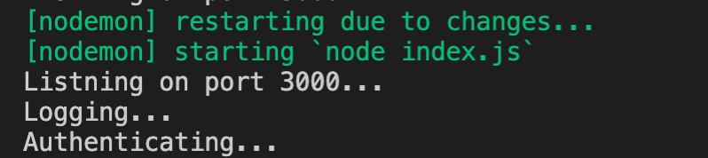

Moving the Middleware code to a separate file

logger.js

function log(req, res, next) {

console.log('Logging...');

next();

}

module.exports = log;

authenticating.js

function authenticate(req, res, next) {

console.log('Authenticating...');

next();

}

module.exports = authenticate;

index.js

const logger = require('./logger');

const authenticate = require('./authenticating');

//adding a piece of middleware

app.use(express.json());

//custom middleware function logging

app.use(logger);

//custom middleware function authenticating

app.use(authenticate);

GET http://localhost:3000/api/courses/

# Built-In Middleware

//built in middleware function

app.use(express.urlencoded({ extended: true }));

POST http://localhost:3000/api/courses/

Content-Type: application/x-www-form-urlencoded

name=my-course

//built in middleware function

app.use(express.static('public'));

create a public folder

Inside public folder .Create a file readme.txt

|  |
| --- |
| This is a readme file! |

GET http://localhost:3000/readme.txt

# Third-party Middleware

Go to : <http://expressjs.com/>

In the resources we have middleware

We will look for helmet

$ npm i helmet

$ npm i morgan

Index.js

//Third-party middleware

const helmet = require('helmet')

const morgan = require('morgan')

//third-party middleware function

app.use(helmet());

app.use(morgan('tiny'));

GET http://localhost:3000/api/courses/

This is morgan(‘tiny’) format: GET /api/courses/ 200 79 - 3.226 ms

# Environments

Is this a development environment or production environment. You want to enable or disable certain features based on the current environment.

Let’s say you want to enable logging up http request only in development environment

app.use(morgan('tiny'));

//Enviornments

console.log(`NODE_ENV: ${process.env.NODE_ENV}`);

console.log(`app: ${app.get('env')}`);

if (app.get('env') === 'development') {

app.use(morgan('tiny'));

console.log('Morgan enabled...');

};

By default : its development

You can see the NODE_ENV is undefine. Let set the NODE_ENV =production

Current env is production. You can see the if condition which check for development environment. The Morgan enabled is skipped.

# Configuration

In the last topic we learnt which environment you application is running. One topic that go hand in hand is the topic of storing configuration settings for the application.And overriding those settings in each environment.

For example, in your development environment you’re going to use a different database for mail server. In this module we’ll discuss how to do configuration setting for your applications and override them in each environment.